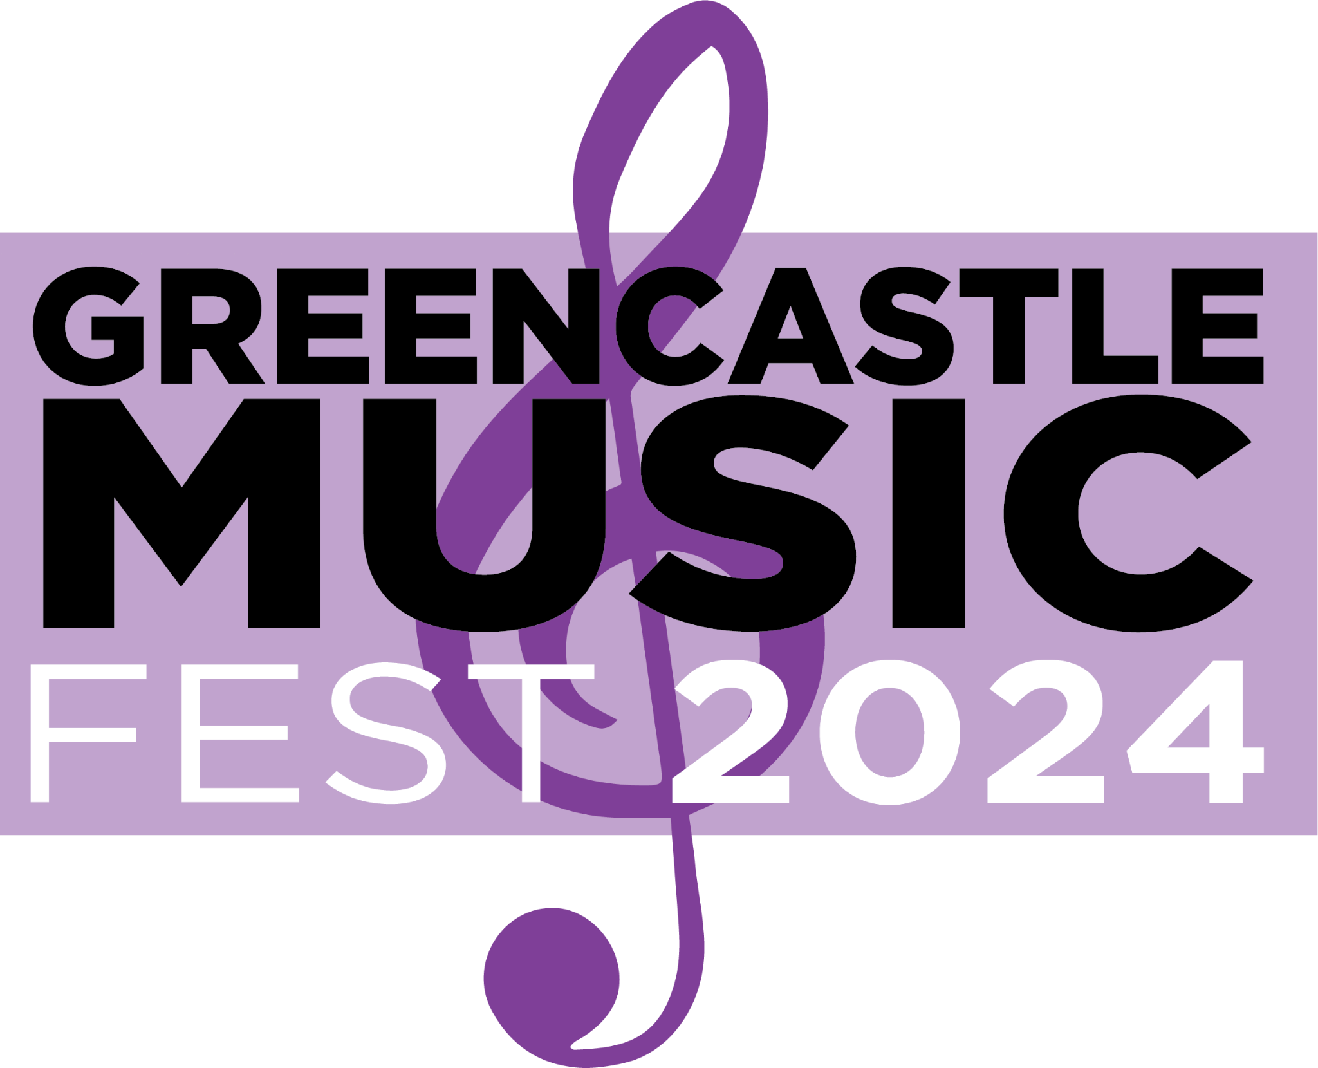

**August 23rd and August 24th, 2024**

**Friday and Saturday**

**greencastlemusicfest.com**

**SPONSORSHIP OPPORTUNITIES**

**2 Big Days of Music**

**Presenting Sponsor $10,000**

* 2 Reserved tables of 6 in VIP Area and free tickets to event
* Individual logo banner hung on stage throughout entire event
* Video board, live mention by MC
* Swag and sponsor beverage opportunities
* Company promoted in all marketing channels – social media, email, print, posters, interviews, video board on stage
* Recognition on Greencastle Music Fest website (logo and link)
* Option for event display (table and/or stand-alone banner)
* Access to the Hospitality Suite with food and restrooms, meet band members and mingle

**Video Board Featured Sponsor $7,500**

* 2 Reserved tables of 6 in VIP Area with free tickets to the event
* Individual logo on video board and live mention by Emcee
* Swag and sponsor beverage opportunities
* Company promoted in all marketing channels - social media, email, print, posters, interviews
* Access to the Hospitality Suite with food and restrooms, meet band members and mingle
* Option for event display (table or stand-alone banner)

**Stage Sponsor $5,000 (4 Available)**

* Reserved table for 6 in VIP Area with free tickets to the event
* Logo on stage banners throughout the entire event
* Highlighted as sponsor in all media promotions – email, social media, print, posters, interviews
* Live mentions by Emcee during the event and on video board
* Recognition on Greencastle Music Fest website (logo and link)
* Swag opportunities
* Access to the Hospitality Suite with food and restrooms, meet band members and mingle

**M2 Hospitality Sponsor $2,500 (Two Days)**

* Provide warm hospitality to musicians, VIP sponsors, and volunteers
* Highlighted as sponsor in all media promotions – email, social media, print, posters, interviews
* Live mentions by Emcee during event and on video board
* Recognition on Greencastle Music Fest website (logo and link)
* Swag opportunities
* Access to the Hospitality Suite with food and restrooms, meet band members and mingle

**Kids Area Sponsor $2,500 (Two Days)**

* Reserved table for 6 in VIP Area with free tickets to the event
* Logo advertised on kids area signage, social media, email promotion, print advertising, posters, video board
* Recognition on Greencastle Music Fest website (logo and link)
* Help ensure fun activities for kids of all ages with giveaways
* Option for event display (table and/or stand-alone banner)
* Access to the Hospitality Suite with food and restrooms

**VIP Area Sponsor $1,500**

* Reserved table for 6 with free tickets to the event
* Logo banner on VIP Area throughout event
* Recognition on Greencastle Music Fest website (logo and link)
* Highlighted as sponsor in social media and email marketing
* Access to the Hospitality Suite with food and restrooms

**Corn Hole Tournament Sponsor $2,500**

* Logo banner near Corn Hole Tournament space
* Highlighted in social media posts before, during, and after event
* Recognition on Greencastle Music Fest website (logo and link) on dedicated corn hole page
* Access to Hospitality Suite with food and restrooms

**Table Sponsor $500**

* Reserved table for 6 with free tickets to the event (may share with public)
* Logo and signage on table throughout event
* Swag opportunities
* Highlighted on social media postings before, during, and after event

**Rock Star Sponsor $250**

* Highlighted in social media posts before and during event and on video

board

* Free tickets to the event (6)

**Guitar Hero Sponsor $100**

* Created for individuals or small businesses that want to support this great event and will receive4 free tickets to the event
* Highlighted on social media and website
* Your photos or logo will be featured on a Guitar Hero Throne on display throughout Music Fest as well as photos of you on the throne



**Sponsorship Commitment Form**

Thank you for your interest and support for the 2024 Greencastle Music Fest. Your support and excitement will help us make this the biggest and best event. Already a destination event, our “Award Winning” Music Fest will again rock the downtown square with locals, friends, family, and music lovers from all over.

If you have any questions or need more information, please contact Gail Smith

at [greencastlemusicfest@gmail.com](mailto:greencastlemusicfest@gmail.com) or 765-721-0137

**Please select your sponsorship level below:**

**___________ Presenting Sponsor $10,000**

**___________ Video Board Featured Sponsor $7,500**

**___________ Stage Sponsor $5,000 (4 available)**

**___________ M2 Hospitality Sponsor $3,000**

**___________ Kids Fun Area Sponsor $2,500**

**___________ Corn Hole Tournament Sponsorship $2,500**

**___________ VIP Area Sponsor $1,500**

**___________ Table Sponsor $500**

**___________ Rock Star Sponsor $250**

**___________ Guitar Hero Sponsor $100**

|  |  |
| --- | --- |
| **Contact Name:** |  |
| **Company Name:** |  |
| **Billing Address:** |  |
| **City, State Zip:** |  |
| **Email:** |  |
| **Phone:** |  |

Please email your commitment sponsorship level to [greencastlemusicfest@gmail.com](mailto:greencastlemusicfest@gmail.com) or mail to GMF 17 W. Franklin St. Greencastle, Indiana 46135. Please indicate your level of sponsorship.

**Please email high resolution logo** to [greencastlemusicfest@gmail.com](mailto:greencastlemusicfest@gmail.com)

We will invoice you next year in the spring. Thank you for your commitment and support for the “Award Winning” Greencastle Music Fest

**Thank you for your support. See you August *23rd* & 24th**